SMART PARKING

PHASE 4: DEVELOPMENT PART 2

IoT Smart Parking project, it can enhance the functionality and user experience by incorporating web development technologies.

Here's how technologies into various aspects of the project:

**Web-based Dashboard for Administrators:**

* Create a web-based dashboard for administrators to monitor and manage the parking system. This dashboard should provide real-time information about parking spot occupancy, reservations, and transaction history.
* Use web development technologies like HTML, CSS, and JavaScript, and consider using a web framework for efficiency.

**HTML/CSS**: Design the dashboard's layout and style using HTML and CSS.

**JavaScript**: Implement interactivity for real-time updates, charts, and user management.

**Web Framework:** You can use popular frameworks like React, Angular, or Vue.js for a organized and responsive interface.

**Mobile App:**

* Develop a mobile app to reserve parking spots, make payments, and receive notifications.
* Use cross-platform mobile app development frameworks like React Native or Flutter to streamline app development for both Android and iOS.
* **API Integration:** Connect the app to the backend server for user authentication, reservation processing, and payment handling.

**Online Reservation System:**

**React Native or Flutter**: Build the app's frontend using these frameworks, which allow you to write code once and deploy it on

Implement a web-based reservation system for students to check parking spot availability and make reservations.

* This system can be integrated with the mobile app and can be developed using standard web technologies.

**HTML/CSS**: Design the reservation interface.

**JavaScript:** Develop interactive features, such as selecting a parking spot and specifying the reservation duration.

**Backend:** Implement reservation logic on the server side, making use of frameworks like Express.js (Node.js) or Django (Python).

**Payment Gateway Integration:**

If you include a payment system, you'll need to integrate a payment gateway into your web app for processing payment.

Popular payment gateways often provide APIs for this purpose. Here's a simplified example using Python and Flask:

**Flask:** Create an API endpoint to handle payment requests.

**Payment Gateway API**: Utilize the API provided by the payment gateway provider (e.g., Stripe, PayPal) for processing payments. **Frontend Integration:** Integrate the payment process into your mobile app or web app, allowing users to enter payment details securely.

**Real-time Updates:**

* Use web development technologies to ensure real-time updates on parking spot availability, reservation confirmation, and payment status.
* You can achieve this with technologies like WebSocket for real-time communication between the server and clients.

**WebSocket**: Implement WebSocket communication to push real-time updates to the web and mobile clients when a parking spot's status changes.

**User Authentication and Management:**

For user authentication and management, you can create user registration and login systems within the mobile app and web interface.

Use web development technologies for user interfaces and backend logic:

**HTML/CSS**: Design registration and login forms.

**JavaScript**: Implement form validation and submission handling.

**Backend**: Create user accounts, manage authentication, and store user data securely in a database.

**Data Analytics and Reporting:**

• Utilize web technologies to create data analytics and reporting features for administrators. You can use JavaScript libraries for data visualization and reporting tools.

**Data Visualization Libraries**: Integrate libraries like Chart.js or D3.js to display parking utilization statistics and trends.

**Backend**: Develop APIs for fetching historical parking data and generating reports.

Python code:

Import time

data (0 for empty, 1 for occupied)

Parking_spots = [0, 0, 0, 0, 0] Def get_parking_status():

Return [random.choice([0, 1]) for _ in range(len(parking_spots))] While True:

Parking_spots = get_parking_status()

# Send parking_spots data to the cloud (simulated)

Print(“Sending data to the cloud:”, parking_spots) Time.sleep(10)

# Simulated data update every 10 seconds

RASPBERRY PI INTEGRATION:

Import time

Import RPi.GPIO as GPIO

Import time

Import os,sys

From urllib.parse import urlparse

Import paho.mqtt.client as paho

GPIO.setmode(GPIO.BOARD)

GPIO.setwarnings(False)

Define pin for lcd

E_PULSE = 0.0005

E_DELAY = 0.0005

Delay = 1

LCD_RS = 7 LCD_E = 11

LCD_D4 = 12

LCD_D5 = 13

LCD_D6 = 15

LCD_D7 = 16

Slot1_Sensor = 29

Slot2_Sensor = 31

GPIO.setup(LCD_E, GPIO.OUT) # E

GPIO.setup(LCD_RS, GPIO.OUT) # RS

GPIO.setup(LCD_D4, GPIO.OUT) # DB4

GPIO.setup(LCD_D5, GPIO.OUT) # DB5

GPIO.setup(LCD_D6, GPIO.OUT) # DB6

GPIO.setup(LCD_D7, GPIO.OUT) # DB7

GPIO.setup(slot1_Sensor, GPIO.IN)

GPIO.setup(slot2_Sensor, GPIO.IN)

LCD_WIDTH = 16 # Maximum characters per line

LCD_CHR = True

LCD_CMD = False

LCD_LINE_1 = 0x80 # LCD RAM address for the 1st line

LCD_LINE_2 = 0xC0 # LCD RAM address for the 2nd line LCD_LINE_3 = 0x90# LCD RAM address for the 3nd line Def on_connect(self, mosq, obj, rc):

Self.subscribe(“Fan”, 0)

Def on_publish(mosq, obj, mid):

Print(“mid: “ + str(mid))

Mqttc = paho.Client() declaration

Mqttc.on_connect = on_connect Mqttc.on_publish = on_publish url_str = os.environ.get(‘CLOUDMQTT_URL’, ‘tcp://broker.emqx.io:1883’) url = urlparse(url_str)

mqttc.connect(url.hostname, url.port)

Def lcd_init()

Lcd_byte(0x33,LCD_CMD) # 110011 Initialise

Lcd_byte(0x32,LCD_CMD) # 110010 Initialise

Lcd_byte(0x06,LCD_CMD) # 000110 Cursor move direction

Lcd_byte(0x0C,LCD_CMD) # 001100 Display On,Cursor Off, Blink Off

Lcd_byte(0x28,LCD_CMD) # 101000 Data length, number of lines, font size

Lcd_byte(0x01,LCD_CMD) # 000001 Clear display

Time.sleep(E_DELAY)

MIT APP INVENTOR:

* MIT App Inventor is a visual programming environment that allows you to create mobile applications for Android devices.
* You can use MIT App Inventor to develop a smart parking application that helps users find available parking spaces, reserve parking spots, and navigate to them.
* Here's a basic overview of how you can create a smart parking app using MIT App Inventor

MOBILE APP:

Creating a mobile app for smart parking involves developing an application that helps users find and manage parking spaces efficiently. Here's a simplified guide on how to create a smart parking mobile app:

1. Define the Features:

- Start by outlining the features you want in your app. Common features include finding available parking spaces, reserving spots, navigation, and payment processing.

2. Choose a Development Platform:

- Decide on the technology stack for your app. Native development (iOS and Android), cross-platform development (using tools like Flutter or React Native), or web-based solutions (PWA) are some options.

3. Design the User Interface:

- Create wireframes and designs for your app's user interface. Ensure that it's user-friendly and easy to navigate.

4. Implement Parking Spot Data:

- Integrate a database or API to store and retrieve parking spot information. This may include location data, availability, pricing, and real-time updates.

5. Location Services:

- Use location services to determine the user's current location and display nearby parking spots on a map. You may need to request location permissions.

6. Real-time Updates:

- Implement real-time updates to display the current status of parking spots, whether they are available or occupied.

7. Reservation System:

- Create a reservation system that allows users to reserve parking spots in advance. This involves managing user accounts and payment processing.

8. Navigation:

- Integrate mapping and navigation services to help users find and navigate to their selected parking spot.

9. Payment Processing:

- Implement secure payment processing for parking reservations. You may need to integrate with payment gateways like Stripe or PayPal.

10. User Profiles and Accounts:

- Allow users to create profiles, store payment information, and view their reservation history.

11. Notifications:

- Send notifications to users about their reservations, parking availability, and other relevant information.

12. Testing:

- Test your app thoroughly to ensure it works as expected. Test on various devices and simulate different scenarios.

13. Security and Privacy:

- Implement security measures to protect user data and transactions. Ensure compliance with data privacy regulations.

14. Deployment:

- Publish your app on the Google Play Store for Android devices and the Apple App Store for iOS devices.

15. Marketing and User Engagement:

- Promote your app to attract users. Consider strategies like social media marketing, app store optimization, and partnerships with local businesses.

16. User Support:

- Provide customer support through the app and offer assistance to users as needed.

* Creating a smart parking mobile app is a significant project, and it may require collaboration with developers, designers, and database administrators.
* Consider legal and regulatory aspects, such as data privacy and compliance with parking regulations in the areas your app will serve.

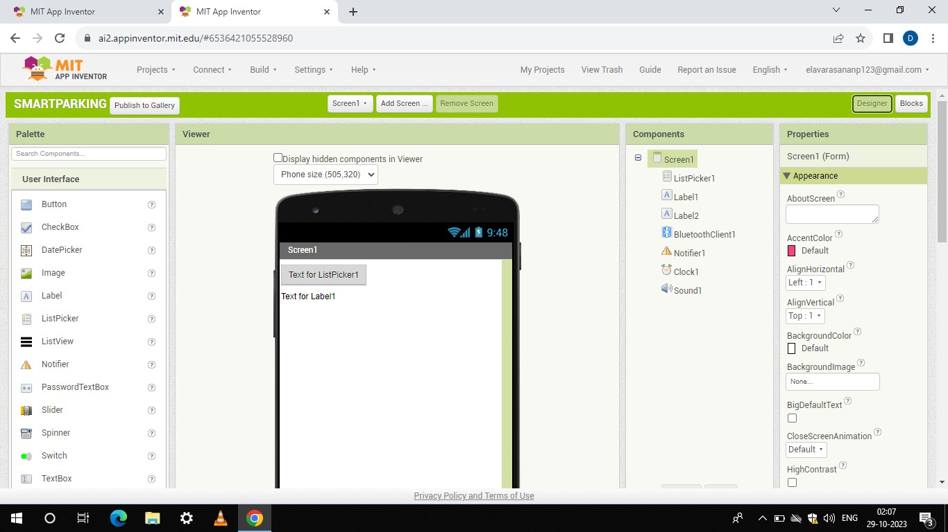

BLOCKS:

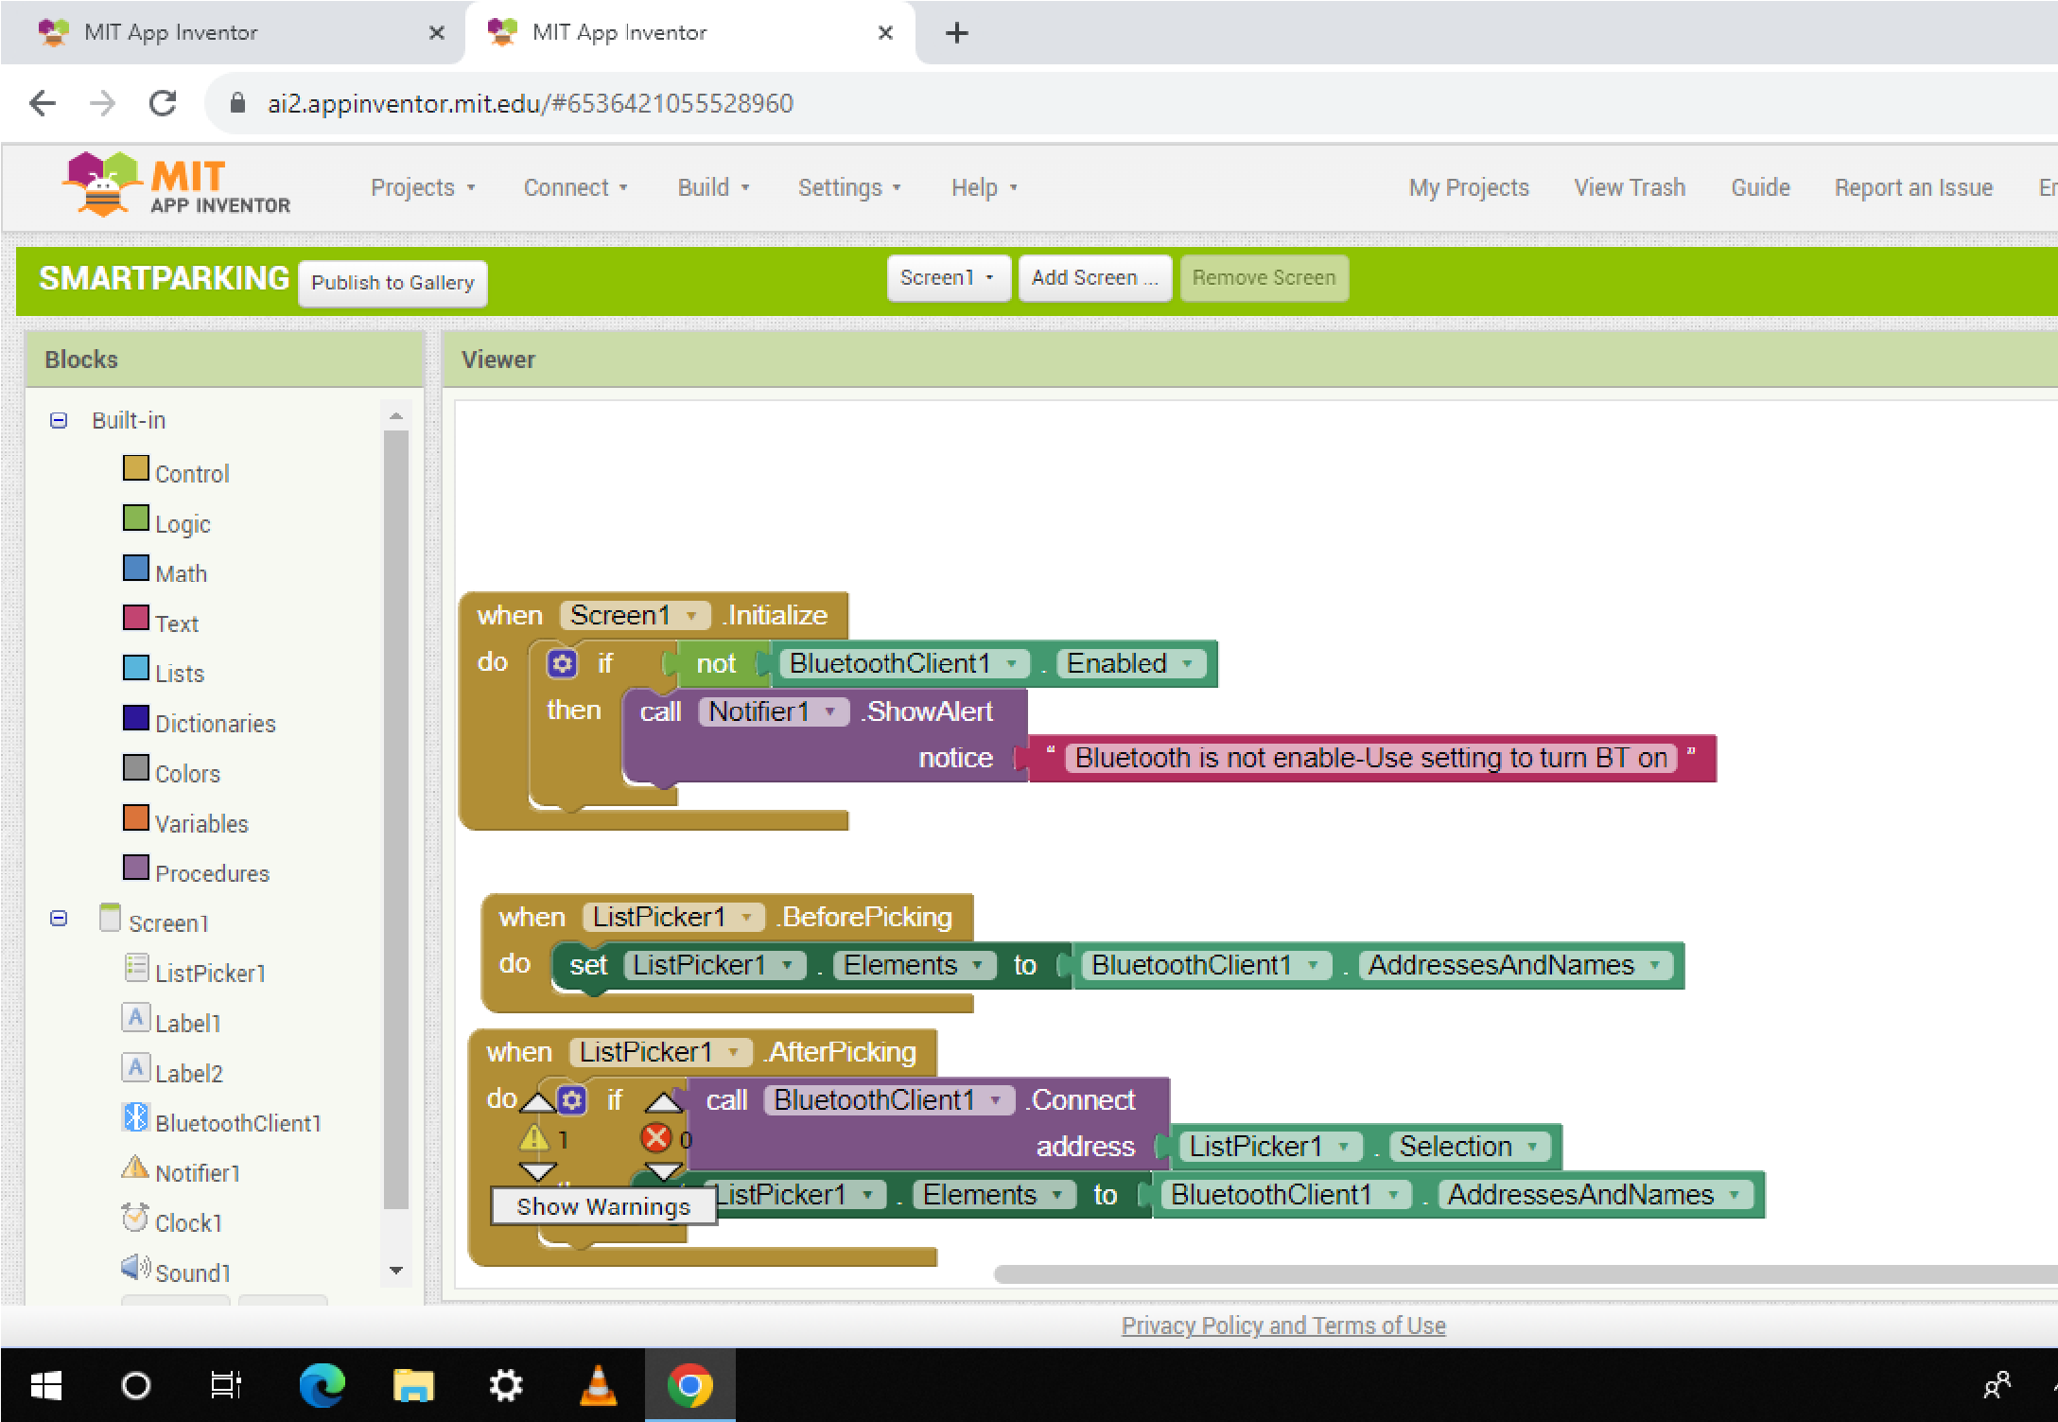

THESE CODE AND IMAGES ARE INCLUDED IN PHASE 4:

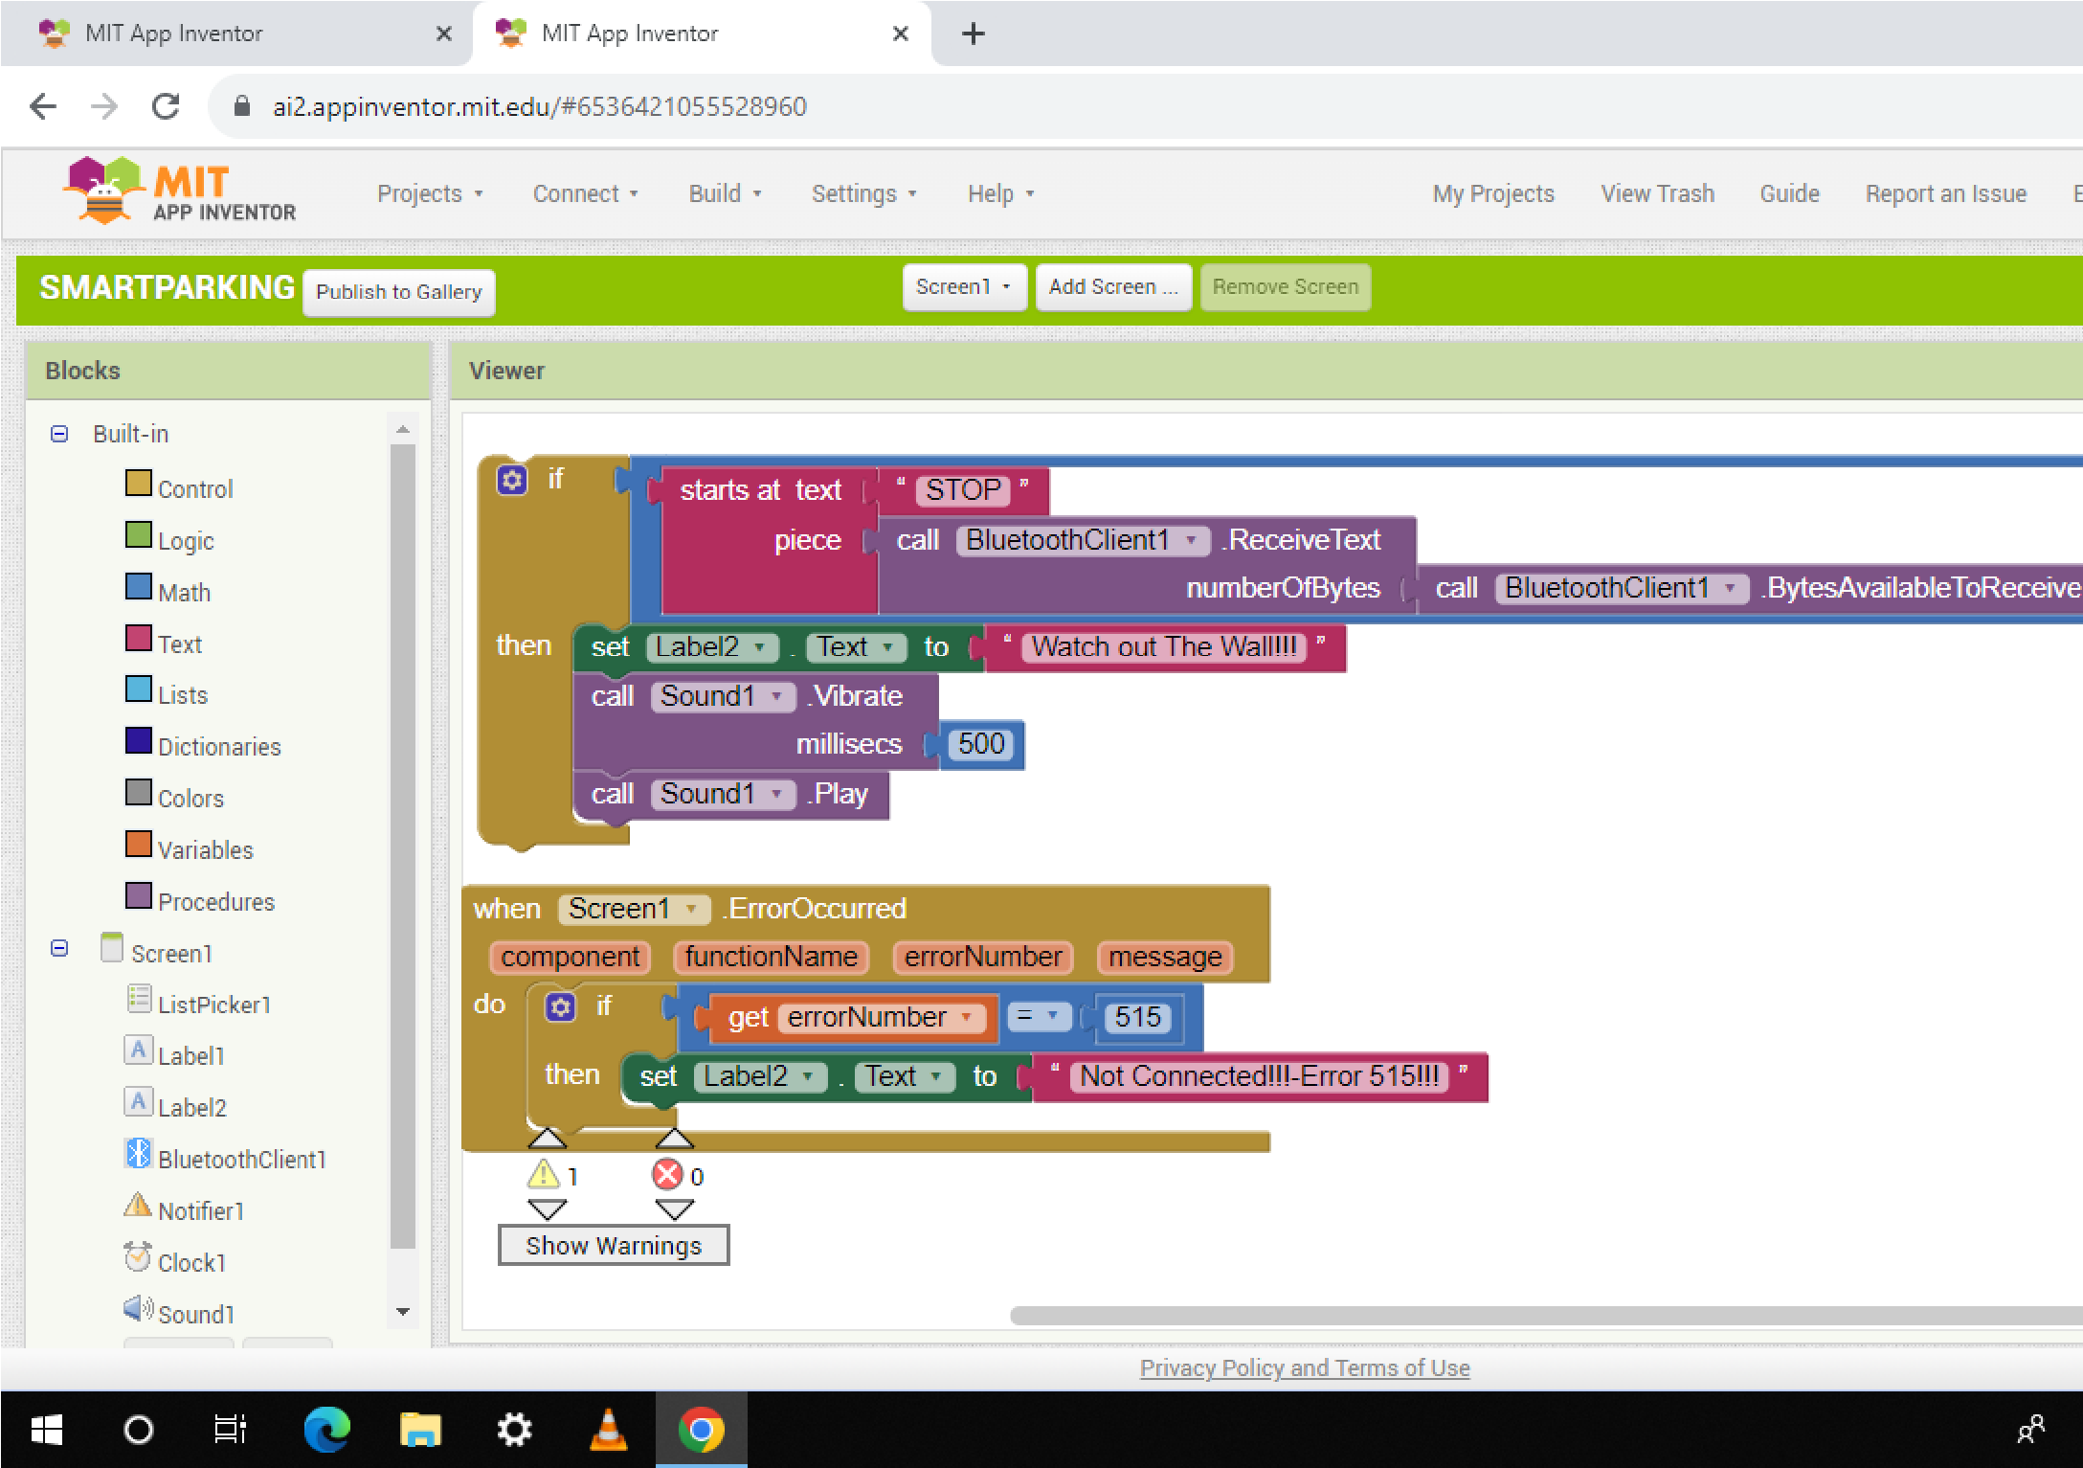

AKASH.

422621104005